16th Place - So Close to Gold Medal
LoRA/QLoRA Efficient Training for LLM
Using LoRA/QLoRA allows us to train a Gemma2-9B-IT model like it is only DeBERTa-v3-base or large wow! If we finetuned the full Gemma2-9B-IT, we would need to update 9 billion parameters. Instead we can use LoRA/QLoRA with rank=64 and only finetune 200k parameters (or use rank=16 and 50k parameters).
For reference DeBERTa-v3-base has 90k parameters and DeBERTa-v3-large has 300k parameters. LoRA works based on linear algebra. If the weights of Gemma2 are (m x n) matrix where m*n=9B, we leave them as is and only find two LoRA matrices of sizes (m x r) and (r x n) where each is about 100k. Then our finetuned model is the product of these two matrices plus the original base matrix. (Of course Gemma2 weights are more than one matrix but you get the idea).
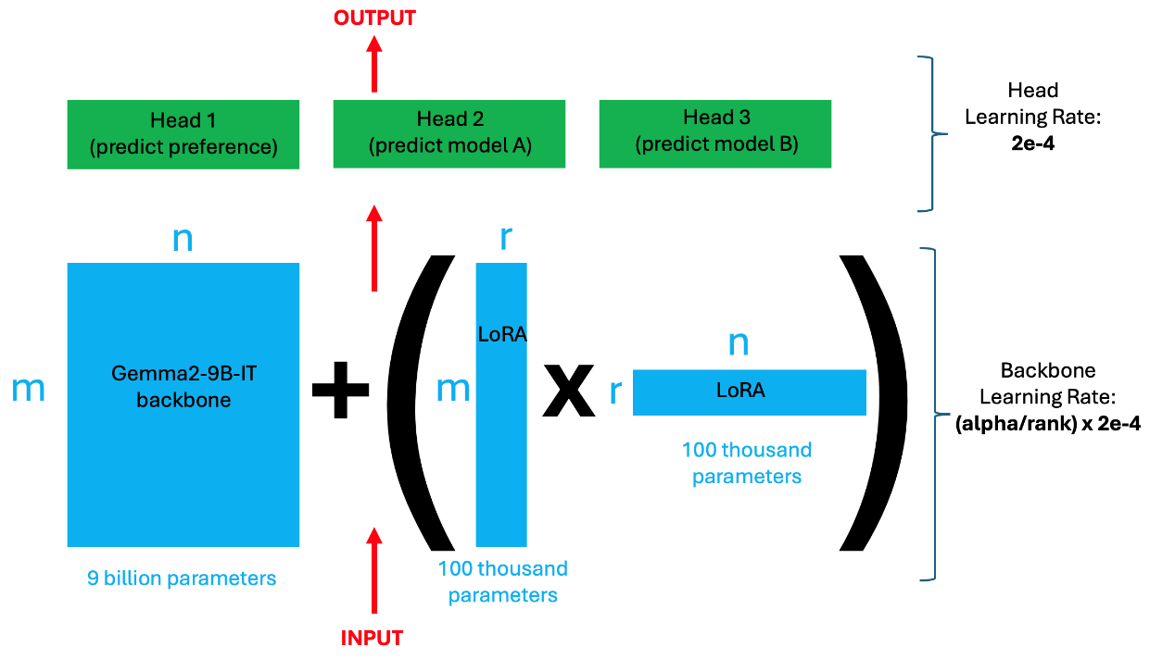
How To Tune LoRA/QLoRA
Using LoRA/QLoRA introduces more variables to tune. Namely we now have r (i.e. rank), alpha, and modules. This is in addition to our usual training parameters learning rate, epochs and batch_size. Here is a strategy to tune everything:
- First pick modules. If possible using all modules will yield best results: target_modules = ["q_proj", "k_proj", "v_proj", "down_proj","up_proj","o_proj","gate_proj"].
- Next pick a learning rate. This will be the learning rate of your model's head. Using 2e-4 or 2e-5 is a good choice. And using full batch size = 8 is good (i.e. bs per gpu times number of GPUs). Use gradient accumulation, gradient checkpointing, or multiple GPU to achieve this batch size. (Note when using model parallelism with HuggingFace trainer then per_device_train_batch_size is actually the full batch size not per device. Also note gradient checkpointing didn't seem to work correctly with HuggingFace trainer).
- Next start with r=16 and try different alphas. The parameter alpha determines the learning rate of the backbone = alpha/rank * head_LR. Do alpha = 2, 4, 8, 16, 32, 64. Train for 1 epoch (linear schedule with warmup). We now have r=16 and corresponding best alpha.
- Keep the alpha we discovered fixed and try different ranks. Above if we used LR=2e-4 then we will find a=4 to be optimal. So now we try r=4,a=4, r=8,a=4, r=16,a=4, r=32,a=4, r=64,a=4 etc (In this comp once we find optimal alpha for one rank, it is also the optimal alpha for all ranks when keeping LR (learning rate) the same).
- We will generally find there is a specific rank r which bisects performance. In this comp rank<16 performs poorly and rank>=16 performs well. (Increasing above r=16 will generally yield slight improvement. For me using r=1024 gave +0.002 boost vs. r=16).
(FYI, if we use LR=2e-4 1 epoch linear schedule with warmup, then a=4 is best alpha for all rank. If we use LR=2e-5, then a=192 is best alpha for all rank. If we use LR=6e-5, then a=64 is best alpha for all rank).
Training with Multiple GPU
Training large LLM using multiple GPU helps with memory and speed. In this competition, I used Nvidia 8xV100 32GB GPUs and sometimes used Nvidia 4xA100 80GB GPUs. Thank you Nvidia for compute resources.
We need to be aware that there are (at least) three ways to parallelize training LLM with multiple GPU. Search for blogs on these topics to learn more. We can use
- data parallelism (each GPU has a copy of LLM and batches are processed in parallel)
- model parallelism (LLM is split over GPUs and batches are processed sequentially)
- hybrid parallelism (LLM is split over GPUs and batches are processed in parallel)
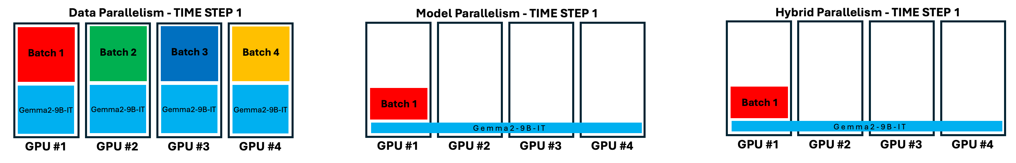
HuggingFace trainer uses the first two. More advanced libraries like Axolotl/DeepSpeed can use the most efficient third one. These affect our training speed and memory requirements. Ideally during training we want all GPUs to be utilized 100%. So we can run nvidia-smi or gpustat -i and adjust our parallel code until we achieve the most efficient use of GPU.
How To Achieve Silver Medal with Public Notebook
Kaggle user @emiz6413 published an amazing starter notebook train here and infer here which achieved LB = 0.941! Thank you Eisuke Mizutani for sharing! With just a few changes, we can boost this public notebook to LB < 0.900 Silver Medal!
- Use TTA! Change tta = False to tta = True boosts LB 0.941 => 0.926
- Change LoRA r=16, a=32, freeze=16 to r=64, a=16, freeze=0 boosts LB 0.926 => 0.913
- Add modules: ["down_proj","up_proj","o_proj","gate_proj"] and use r=64, a=4 boost LB 0.913 => 0.903
- Add external 33k dedup dataset here and train with 100% data boost LB 0.903 => 0.899 Silver Medal!
How To Almost Achieve Gold Medal (i.e. 16th place)
Starting from above, we can almost achieve gold medal (i.e. 16th place) with the following updates:
- Train with max=2048 vs max=1024 boost LB 0.899 => 0.895
- Change LoRA r=64, a=4 to r=1024, a=4 boost LB 0.895 => 0.894
- Use LoRA train fp16 infer 8bit instead of QLoRA train 4bit infer 4bit => 10% inference speedup!
- Infer with max=3072 (and avoid timeout with 8bit quant above) boost LB 0.894 => 0.893
- TTA with two different Gemma2 boost LB 0.893 => 0.891
- Infer 3 heads (preference, model_a, model_b discard last two) boost LB 0.891 => 0.890
- Truncate from left vs right boost LB 0.890 => 0.885 Almost Gold Medal!
Truncate Left instead of Truncate Right
One of the biggest boosts came from truncating long text from the beginning (i.e. left side) instead of the ending (i.e. right side):
def prepare_text(self, prompts, responses_a, responses_b):

prompts = json.loads(prompts)
responses_a = json.loads(responses_a)
responses_b = json.loads(responses_b)

rounds = [
f"<start_of_turn>prompt\n{prompts[i]}<end_of_turn>\n"
+f"<start_of_turn>response_a\n{responses_a[i]}<end_of_turn>\n"
+f"<start_of_turn>response_b\n{responses_b[i]}<end_of_turn>"
for i in range(len(prompts))
]

for k in range(len(rounds)):
text = "\n".join(rounds[k:])
if len( self.tokenizer(text)["input_ids"] )<3072: break

return text
LLama3.1-405B-as-a-Judge
I read research papers that said LLM-as-a-Judge performed similar to humans. So during the competition I tried many times to use Llama3.1-405B to create synthetic data to improve CV and LB score. I tried 3 ideas but none of them worked. :-(
In each scenario below, I employed few shot learning. I would show Llama 10 to 20 examples of real train data then ask Llama to create something. I would provide a detailed system prompt in addition to user prompt:
- Show Llama3.1-405B fifteen examples and ask Llama3.1 to create new train data
- Show Llama3.1-405B ten examples and prompt-responseA from lmsys-1M-dataset and ask Llama to create responseB and target
- Show Llama3.1-405B twenty examples and prompt-responseA-responseB pairs from lmsys-1M-dataset and ask Llama to create target. Local validation showed that Llama was achieving around logloss = 0.95 but this data did not help.
Post Competition Experiments
I'm curious to learn what I missed to achieve Gold Medal. I will read other top solutions and try to incorporate new ideas into my final solution and make late submissions to LB. I will update this section if I discover anything that boosts my CV and LB score into Gold Medal zone!
UPDATE: Published Single Model Code
I published the code to reproduce my best single model of CV 0.878 and LB 0.888 (on original public LB data). There are three Jupyter notebooks
- Train (1 of 3) here
- Quantize (2 of 3) here
- Infer (3 of 3) here
The first two public notebooks (1 and 2) use settings to train with QLoRA and quantize to 4bit in order to work within Kaggle's 2xT4 16GB GPUs. If we do this, then we can only infer with max token 2048 and achieve LB 0.889. If we train these notebooks offline, we can change the settings to use LoRA and quantize to 8bit and infer max token 3072 and achieve LB 0.888.
19th Place Solution
First of all, I would like to express my gratitude to Kaggle and LMSYS for organizing this incredibly interesting and educational competition. I also want to thank my teammate @cody11null for contributing valuable ideas and facilitating effective communication within the team. Special thanks to teammate @mohammad2012191, who also provided valuable tricks and contributed significant computational resources, making important explorations in post-model processing. I also want to acknowledge teammate @lihaoweicvch for his valuable ideas and strong computational support, as well as for his excellent work in resolving the time-out issues with the inference code. Without the efforts of these three teammates, our team wouldn’t have achieved the success we have today.
Additionally, I would like to extend my special thanks to @emiz6413. It was his open-source infer notebook train notebook that motivated me to fully commit to this competition. His open-source spirit embodies the true essence of Kaggle, and I deeply admire his dedication.
In the following, I will mainly discuss our solution in three parts: firstly, the key tricks; secondly, my exploration throughout this competition; and finally, the potential optimization points and unresolved issues in this competition.
key tricks
1. add o_proj, gate_proj to the target_modules in lora_config
lora_config = LoraConfig(
r=config.lora_r,
lora_alpha=config.lora_alpha,
target_modules=["q_proj", "k_proj", "v_proj", "o_proj", "gate_proj"],
layers_to_transform=[i for i in range(42) if i >= config.freeze_layers],
lora_dropout=config.lora_dropout,
bias=config.lora_bias,
task_type=TaskType.SEQ_CLS,
)
cv improve about 0.12
lb improve about 0.08(single model)
add : I will share the key experimental data in detail below.
2.improve training max_len to 3072
cv improve about 0.02
lb improve about 0.05(single model)
3.Set the number of frozen layers to 0
cv improve about 0.17
lb improve about 0.11(tta)
4.add external data
cv improve about 0.06
lb improve about 0.12(tta)
5.increase lora_r to 64
cv improve about 0.06
lb improve about 0.09(tta)
add if we stop here we can actual won a gold medal in the new test haha :)😄
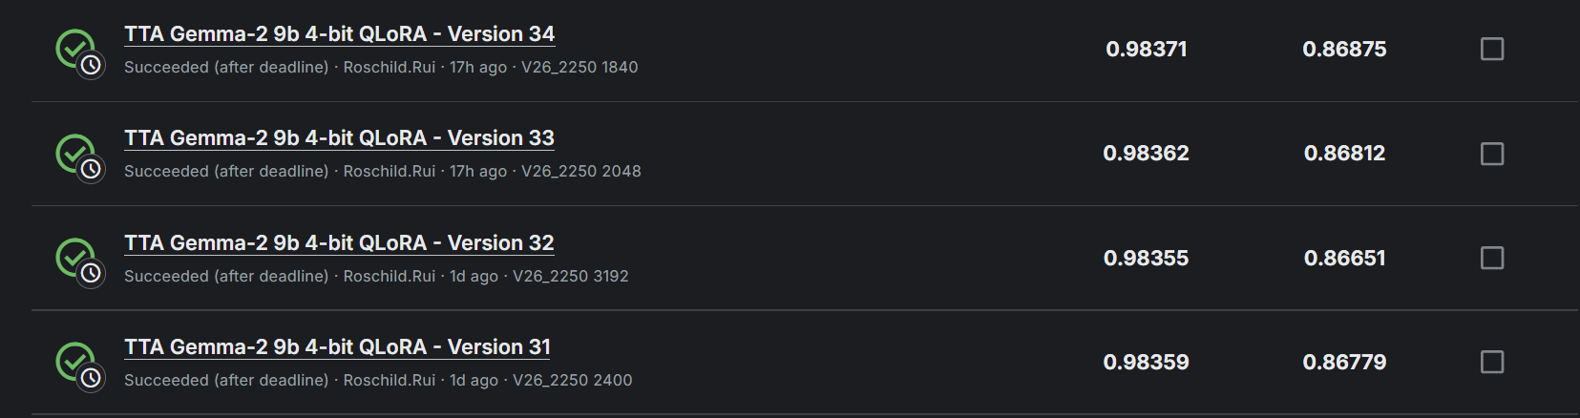
6.design a simple new header to replace the model.score
class CustomClassificationHead(nn.Module):
def __init__(self, config):
super().__init__()
self.fc1 = nn.Linear(config.hidden_size, config.hidden_size * 2, bias=False)
self.fc2 = nn.Linear(config.hidden_size * 2, config.hidden_size // 2, bias=False)
self.fc3 = nn.Linear(config.hidden_size // 2, config.num_labels, bias=False)

def forward(self, features):
x= self.fc1(features)
x= self.fc2(x)
x= self.fc3(x)
return x
cv improve about 0.03
lb improve about 0.04(tta)
Complete exploration process and key experimental data
Try deberta
The training and inferring notebook public here
Try Gemma-2-9B-it
Almost all the model weight i public here
and some in kaggle dataset
infer without head revised public here -> gold score haha :)
Gemma-9B-it key experiment data
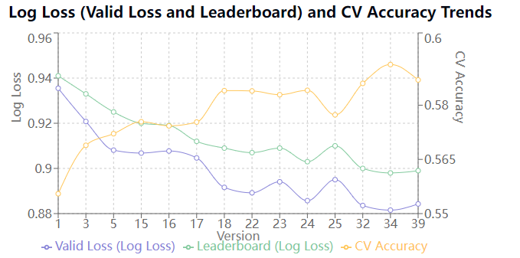
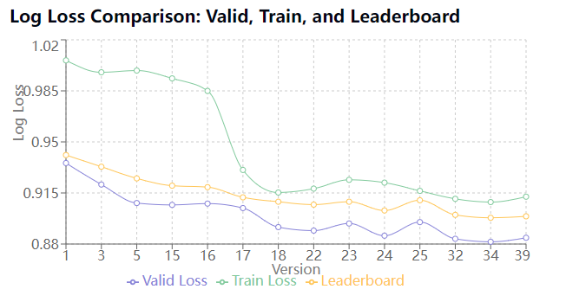
VER py_ver trick cv cv_acc train_loss lb n_epochs max_length bs gra_acc lr lora_r lora_alpha accelerator
1 1 original 0.935504 0.555498 1.005892 0.941 1 1024 4 2 2.00E-04 16 32 A100-40G
3 1 improve max_length 0.92079 0.568894 0.997738 0.933 1 2048 2 4 2.00E-04 16 32 A100-40G
5 4 add o_proj, gate_proj 0.908097 0.572112 0.998925 0.925 1 2048 8 4 2.00E-04 16 32 A100-80G
15 4 add o_proj, gate_proj+try long+inter 3072 0.906807 0.575418 0.993547 0.92 1 3072 2 8 2.00E-04 16 32 A100-40G
16 4 add o_proj, gate_proj+try long+freeze0+infer 3072 0.90772 0.574287 0.984961 0.919 1 3072 2 16 2.00E-04 16 32 A100-40G
17 mixed data+add o_proj, gate_proj+try long 0.904647 0.575331 0.930781 0.912 1 3072 2 16 1.00E-04 16 32 A100-40G
18 mixed data+add o_proj, gate_proj+try long+freeze0 0.891603 0.584029 0.915302 1 3072 2 16 1.00E-04 16 32 A100-40G
22 mixed data+add o_proj, gate_proj+try long+freeze0+increase r 0.889211 0.583942 0.917987 1 3072 2 16 1.00E-04 32 64 A100-40G
23 mixed data+add o_proj, gate_proj+try long+freeze0+increase r 0.894082 0.582898 0.924007 1 3072 2 16 1.00E-04 24 48 A100-40G
24 mixed data+add o_proj, gate_proj+try long+freeze0+increase r 0.885727 0.584116 0.92209 1 3072 2 16 1.00E-04 48 96 A100-40G
random tta v18 0.906 3072
v18 tta 0.908 2048
v17 cp2000 tta 0.919 1536
v18 cp2000 tta 0.911 1536
v18 cp2000 tta 0.906 2000
v18 cp2000 tta 0.906 2100
v21 cp2100 0.913 3072
v21 cp2100 tta 0.905 2000
particular tta 0-1024 non tta 0.91
particular tta 0-1536 non tta 0.91
25 lora_alpha = 32 +mixed data+add o_proj, gate_proj+try long+freeze0+increase r 0.895018 0.577331 0.916444 1 3072 2 16 1.00E-04 64 32 A100-40G
26 n_split = 10+mixed data+add o_proj, gate_proj+try long+freeze0+increase r 0.869383 0.591336 0.925077 1 3072 2 16 1.00E-04 48 96 A100-40G
27 n_split = 50+mixed data+add o_proj, gate_proj+try long+freeze0+increase r 0.858467 0.607826 0.933301 1 3072 2 16 1.00E-04 64 128 A100-40G
28 new mixed data+add o_proj, gate_proj+try long+freeze0+increase r 0.593338 0.758525 0.844598 1 3072 2 16 1.00E-04 64 128 A100-40G
29 n_split = 100+mixed data+add o_proj, gate_proj+try long+freeze0+increase r 0.832338 0.615652 0.929202 1 3072 2 16 1.00E-04 64 128 A100-40G
30 continue train based on v29 cp2440 0.828129 0.626087 0.898
32 new_score_head n_split = 5 0.883596 0.58603 0.910986 1 3072 2 16 1.00E-04 64 128 A100-40G
33 new_score_head n_split = 10 0.869587 0.598643 0.91562 1 3072 2 16 1.00E-04 64 128 A100-40G
v26_2250 0.895 2000
v26_2200 0.896 1900
v27_2200 0.899 1920
v27_2200 0.903 1536
v29_2440 tta 0.894 1776
34 new head + alpha = r 0.881545 0.591249 0.908757 1 3072 2 16 1.00E-04 64 64 A100-40G
35 new head + alpha = r n_split = 10 1 3072 2 16 1.00E-04 64 64 A100-40G
36 attn head + alpha = r 1 3072 2 16 1.00E-04 64 64 A100-40G
37 linear head+ bf16 + eager n_split = 10 1 3072 2 16 1.00E-04 64 64 A100-40G
38 linear head+ bf16 + eager n_split = 50 0.858054 0.606957 0.911753 1 3072 2 16 1.00E-04 64 64 A100-40G
39 linear head+ bf16 + eager n_split = 5 0.884285 0.586987 0.912451 1 3072 2 16 1.00E-04 64 64 A100-40G
40 ipynb+n_split = 10+mixed data+linear head+ bf16 + eager 0.840444 0.619868 0.934066 1 3072 2 16 1.00E-04 64 64 A100-40G
41 ipynb+n_split = 100+mixed data+linear head+ bf16 + eager 0.831409 0.636522 0.915951 1 3072 2 16 1.00E-04 64 64 A100-40G
42 ipynb+n_split = 5+mixed data+linear head+ bf16 + eager 0.842306 0.612661 0.925324 1 3072 2 16 1.00E-04 64 64 A100-40G
v38_2422 tta 0.892 2048
mix_data : comp data +21k external data
Try Llama3.1-8B-it
i have changed a padding token. Download the new complete revised model file and trained weight at here
training scripts
Llama3.1-8B-it experiment data
VER py_ver trick cv cv_acc train_loss lb n_epochs max_length warmup_steps warm_radio bs gra_acc lr lora_r lora_alpha lora_dropouut lora_bias accelerator
1 1 original 0.981412351 0.516527488 1.06309152 1 2048 20 0 4 8 2.00E-04 16 32 0.05 none A100-40G
2 1 improve max_len 0.976300371 0.522442589 </td> 1 3072 20 0 2 8 2.00E-04 16 32 0.05 none A100-40G
3 2 sft 0.931414843 0.555671538 0.974404319 1 3072 20 0 2 8 1.00E-04 16 32 0.05 none A100-40G
4 2 sft+mix_data 0.921216846 0.562021573 0.924224623 1 3072 20 0 2 8 1.00E-04 16 32 0.05 none A100-40G
5 2 sft+mix_data+o_proj+gate_proj 0.922720075 0.564631176 0.924524553 1 3072 20 0 2 8 1.00E-04 16 32 0.05 none A100-40G
6 2 sft+mix_data+o_proj+gate_proj+dense 0.920885503 0.561325678 0.924782057 1 3072 20 0 2 8 1.00E-04 16 32 0.05 none A100-40G
mix_data : comp data +21k external data
Potential optimization points and unresolved issues
Potential optimization points
1.left truncation
2.Use 8-bit to accelerate inference
3.Add two prediction heads to predict which two models provided response_a and response_b
4.EMA
5.more strong related data
Unresolved issues
1.Two stages fine-tuning struggles to converge
2.knowledge distillation hard to find a good method
3.hard to ft full parameters to get a good cv result
4. @mohammad2012191 public here

